Simulation Specification Report
RECUE milestone

Guy Even & Moti Medina
School of Electrical Engineering
Tel-Aviv University
1/7/09

Abstract
The performance of the frequency assignment and time slot scheduling algorithm [4] will be evaluated by the simulator. The simulator models Wi-Fi communication in which the nodes are capable of synchronous hopping between frequency channels. The simulator is developed using OMNeT++.

Terminology. We address Wi-Fi data units as packets. We address stream data
units as Frames. We address a time slot (or a slot) as the scheduler's discrete time unit [4].

Organization. The report is organized as follows. Section 1 handles the model. The simulation platform is described in Section 2. A block diagram is given in Section 3. The interpretation of the scheduler output by the nodes is described in Section 4. The specification, generation & accumulation of the streams are described in Section 5. The management of the queues is described in Section 6. The simulator's output is described in Section 7. Future work and questions are raised in Section 8. A parameters list and the path-loss model are described in Appendix A and B, respectively. The assumptions are listed in Appendix C.

- Model.

Each node implements Wi-Fi 802.11 (b,g or n).
The nodes communicate according to a freq/time-slot table.

The power of a received signal is speciﬁed by a path loss formula (B.1) (see Appendix B).
The calculation of interference is computed by dividing the reception power by the interference power plus the noise, i.e., SINR. A threshold parameter Beta determines whether a signal is successfully received, e.g., SINR > Beta, or not.

We consider an optional extension in which a successful reception of a signal is a probabilistic function of the SINR.

We allow the interference power to be any function of the interfering signals, e.g., a linear function. More advanced modulations may require non-linear functions.

- Simulation Platform.

The simulator is developed using OMNeT++. OMNeT++ is a public-source, component-based, modular simulation environment with strong GUI support. OMNeT++ provides the basic machinery and tools to write simulations, but itself it does not provide any components specifically for computer network simulations, queuing network simulations, system architecture simulations or any other area. Instead, these application areas are supported by various simulation models and frameworks. These models are developed completely independently of OMNeT++. Our simulator will use a framework for wireless and mobile networks.

- Block Diagram.

In this section we outline the three main building blocks (as depicted in Figure 3.1) of the simulator. More elaborate specifications are given in Sections 4 – 7.

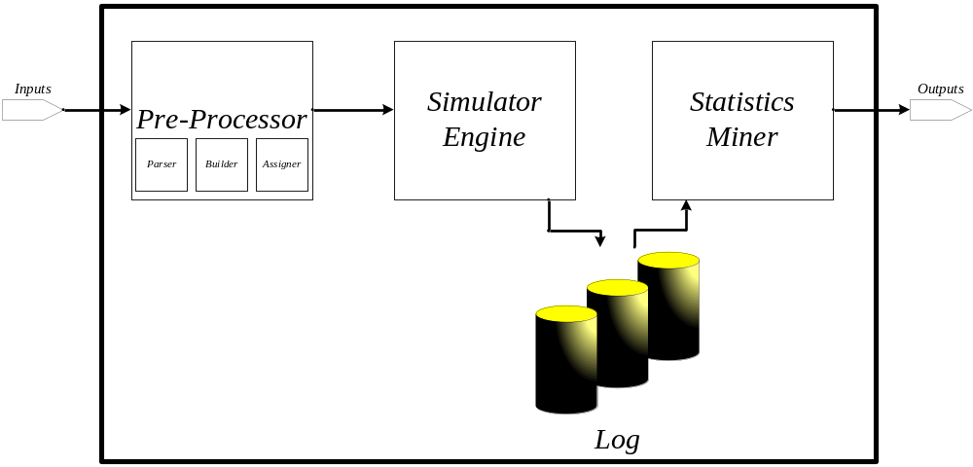
Figure 3.1: Simulator Scheme. The three main blocks are (a) The Pre-Processor (b) The Simulator Engine (c) The Statistics Miner.

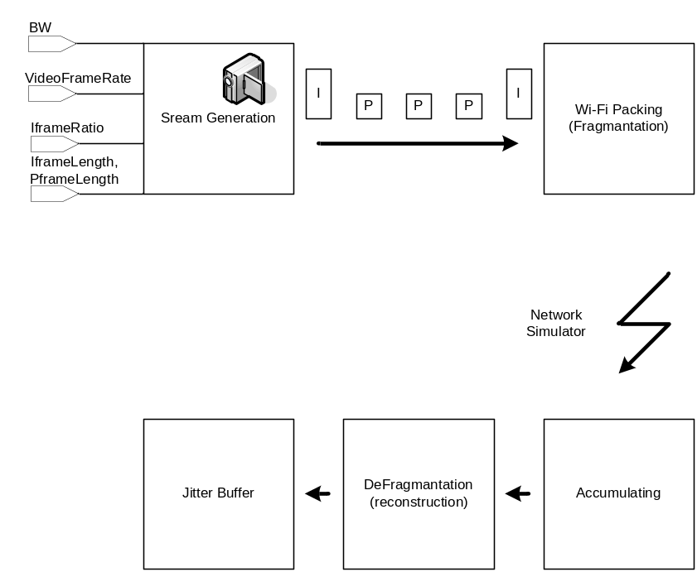
Figure 3.2: Simulator Engine Scheme.
Pre-Processor. Parses the input (the outputs of frequency assignment and time slot scheduling algorithm [4], and the scenario generator). Builds the network and assigns the relevant values for each node in a sequential manner. More elaborate specification is given in Section 4.

Simulator Engine. The simulator engine uses the parameters assigned in time slot t for the interval of time slots [t, t + δ], where δ∙TimeSlotWidth will be roughly 100 seconds (e.g., the "contract" is valid for that time period only). The engine simulates the parsed input for δ time slots. Each source node generates a stream according to an input scenario (e.g., MPEG stream). A log of the simulation is saved. More elaborate specification is given in Section 4-6.

Statistics Miner. Produces the outputs of the simulator. The statistics miner reads the log and produces the required statistics. More elaborate specification is given in Section 7.

- The Interpretation of the Scheduler Output by the nodes.

Simulation Input. The input to the simulation is the output of the scheduler module [4] and the scenario generator. The input is as follows.

- The location of each node, i.e., x,y coordinates.
- Stream list table.
  - Stream ID.
  - Source node.
  - Required BW (e.g., bit/sec).
  - Number of destinations.
  - List of destination nodes.
- The traffic in each slot is described by a traffic hypergraph.
- Each hyperedge is rooted i.e., the source of the traffic.
- The remaining nodes in the hyperedge are the destinations of the traffic.
- Each hyperedge is assigned with:
  - A traffic bandwidth (e.g., bit/sec) that speciﬁes the rate in which the traffic should be sent.
  - Distances from root to other nodes in the hyperedge.
  - The frequency channel.
  - Modulation.
  - Transmition power.
  - Stream type (optional).
  - Queues' length prediction in each node of the hyperedge (see Section 6).
  - Average number of packets (e.g.,Wi-Fi Packet) (a.p.p.s.).
- Number of slots in a cycle, Tlength.
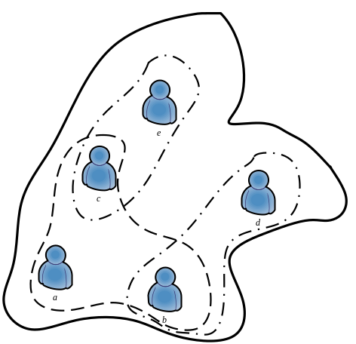
Figure 4.1: The thick line represents the requirement of a certain stream (e.g., a node may participate in more than one stream). The dashed line is an example to the traffic as inputted by the scheduler, e.g., multicast: the source is node a. The destinations are nodes b-e. Stream transmission uses two edges ((c,e) and (b,d)) and the hyperedge (a,b,c).

We emphasis that every node in the hypergraph has a copy of the entire schedule (i.e., The freq/time slot assignment table), in the sense that every node reads, in a synchronized manner the current line in the table.

Simulator Eng. Interpretation. Initially, we ignore modulation, transmission power, stream type.
The input is valid for δ time slots. Each node executes a line in the scheduling repetitively until slot number δ. Hence, each node is in one of three states: Transmit, receive, Do nothing. Every node executes a line exactly for one time slot. We consider an adaptive node with respect to its traffic bandwidth (t.b.). If the SNR is "low" then the t.b. is decreased, if the SNR is high the t.b. is increased.

- The Specification, Generation & Accumulation of the Streams.

In this section we elaborate on specification, generation and accumulation of the Streams, see Figure 3.2 for a block diagram.

Specification. There are three stream types: data, voice and video (e.g., MPEG).
We disregard the differences between the streams at this point and focus on MPEG-like streams. Each stream has two types of frames: I-frame, P-frame. The length of I-frame and P-frame is denoted by IframeLength , PframeLength, respectively. A typical stream is a sequence of frames of the form: I,P,P,P,…,I,P,P,…,I…. The ratio #Iframe/(#Iframe+#Pframe) is given by the parameter IframeRatio. The serial number of a frame in that sequence is saved in the frame's header. We refer to that position as index. The camera's frame rate is given by the parameter VideoFrameRate.

Generation. Each line in the input stream list table represents a stream. A sequence of frames is generated according to the specification. The frames are partitioned to Wi-Fi packets. The Wi-Fi packet length is given by the parameter PacketLength.

Accumulation. Each packet is labeled with its frame's number. The packets are accumulated in the packet queue until a complete frame has been reconstructed.
Upon reconstruction, or defragmentation, the frame (I or P) is passed to the jitter buffer. The jitter buffer passes frames to the application according to their indices (e.g., in the same order they were transmitted). The possible failures that we consider, with respect to the jitter buffer, are as follows. Each frame has a "deadline" that is given by the parameter MaxStreamDelay. Entering the jitter buffer after the deadline means it is not displayed.

- The Management of the Queues.

Each node allocates a queue for each stream, if the stream is routed through the node: A packet queue.
Each destination node allocates an additional queue for each stream, if the node is the stream's destination: A jitter buffer. That allocation expires upon schedule expiration (e.g., after δ time slots). The jitter buffer size is set initially to MaxStreamDelay x Required BW (see 4.b.c). The packet queue size is according to the prediction in the input (see 4.c.3.g). The number of packets that a node can transmit in a time slot is a.p.p.s. (i.e., part of the input. see 4.c.3.i).

- Simulator's Output.

The parameters to be checked by the simulation include:
- Obtained bandwidth vs. required bandwidth per stream (Application Layer).
- Actual queue length per stream (Application Layer).
- Packet error rate per stream per node (Channel Layer). Every failure is labeled with the cause of the failure, i.e.,
  - Due to interference (P/N ok but P/(N+I) too small).
  - Due to low reception power (P/N too small).
- Packet delay from end to end (Channel Layer).
- Jitter buffer delay (Application Layer).
- "Black Screen" time as a function of the jitter buffer length (Application Layer).

- Future Work and Questions.

- How long is the traffic successfully transmitted according to the contract?
- Can we assume that NICS support multi-cast (i.e., definition of group, updating a group, etc.)?
- Ack per packet or ack per slot - We may add additional slots in the schedule for ack accumulation, i.e., after a time slot, where packets were transmitted, there will be a time slot that will be devoted to accumulate the matching acks, followed by a decision whether to proceed or to retransmit? That issue should be dealt with future "Flow Control" module (e.g., a node that repeatedly does not receive the transmission will be removed from the multicast group)? What do we do in multicast?
- Handling voice, data and video streams differently in the simulation, e.g., we initially simulate MPEG-like streams (see Section 4, 5).
- Handling different modulation types and different power transmission per node per stream – Interference models (see Section 4).
- What is the MaxStreamDelay with respect to data, voice and video streams (see Section 5)?
- A definition of "Black screen" time that is dependent, also, on loss of different types of frames (e.g., losing a Pframe has a different effect as losing an Iframe).
- A path loss model & interference model for 802.11g and 802.11n is required for a matching simulation.
- Allow each hyperedge to serve more than one stream per time slot (see Section 4).
- Allow root of hyperedge to participate in more than one hyperedge per time slot (see Section 4).
- Considering an extension in which a successful reception of a signal is a probabilistic function of the SINR (see Section 1).

Bibliography.

  - http://en.wikipedia.org/wiki/WiFi.
  - http://en.wikipedia.org/wiki/802.11.
  - Wireless information networks By Kaveh Pahlavan, Allen H. evesque.
  - Frequency and Time Slot Assignment Algorithm Report By Guy Even, Moni Shahar, Alexander Zadorojniy.

Appendix A: Parameters List.

In this section we summarize all the parameters that the simulation takes into account.

# | Parameter | Units | Appears in | Remarks
1 | ClockSkew | Seconds | Appendix C
2 | Delta (= δ) | Time slots | Sections 3,4,6 | Roughly Delta*TimeSlotWidth=100 seconds
3 | TimeSlotWidth | Seconds | Section 3 | Translates from "table time" to real time.
4 | MaxStreamDelay | Seconds | Sections 5,6,8 | Maximal frame to frame delay
5 | PacketLength | bits | Section 5 | Wi-Fi packet length
6 | IframeLength | bits | Section 5 | I-frame length
7 | PframeLength | bits | Section 5 | P-frame length
8 | IframeRatio | - | Section 5 | #Iframe/(#Iframe+#Pframe)
9 | Protocol | 802.11+{b,g,n} | Appendix A
10 | PathLossConst | dB | Appendix B | Usually 41.01dB or 44.01dB
11 | PlCoeff_d | - | Appendix B | Usually 41.78
12 | PlCoeff_f | - | Appendix B | Usually 32.16
13 | Beta | dB | Section 1
14 | VideoFrameRate | Video Frames/sec | Section 5 | The actual frames per second of the camera

Appendix B: Path-Loss Model for Macrocells.

The following formula describes the path-loss, in dB, for macrocells (urban and suburban environments) for 802.11b by Elbit.

Notations:
- Base station antenna height in meters.
- Mobile station antenna height in meters.
- Carrier frequency in megahertz.
- Distance in kilometers.

Given that then:

.

The case (urban or suburban) is given by the parameter PathLossConst. Let us denote the coefficient of by PlCoeff_d, and the coefficient of by PlCoeff_f, then:

(B.1)

Let us denote the transmission power by , then the received signal power is:
.

Appendix C: Assumptions.

- We assume that clock skew, ClockSkew, is negligible with respect to the scheduler's timeslots [4], therefore the clock is considered to be the same in all the nodes (e.g., synchronized model). Hence, the nodes are capable of synchronous hopping between frequency channels.
- Modulation, transmission power, stream type (e.g., we disregard the difference between these streams) affect interference and reception (see Section 4, 5).

